Join our E-List (group E-Mail)
1) Login to TellicoLife
2) Go to Quick Links on the right side of the TellicoLife page and click on My Profile
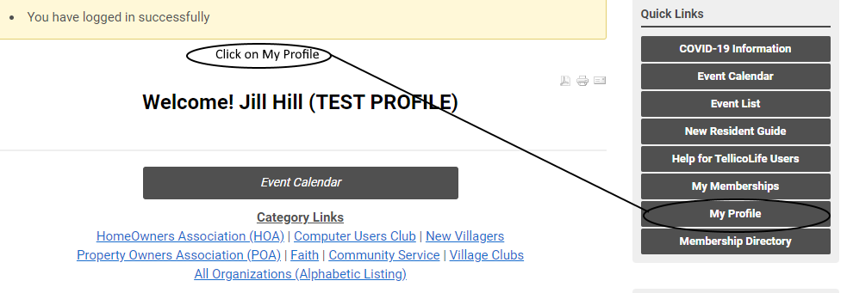
3) Go to My Features at the center of the page and click on the drop down “E-Lists”.
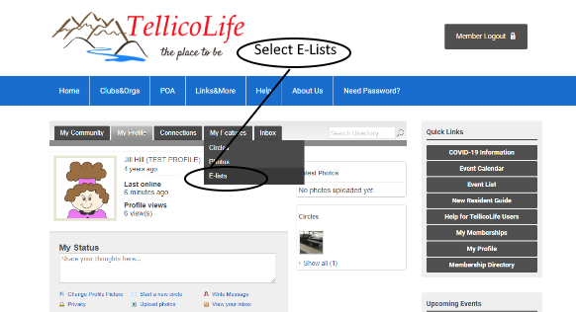
4) Find the row for Ladies_Luncheon. Slide the switches for Subscribe and Email Delivery to the On “Green” position.
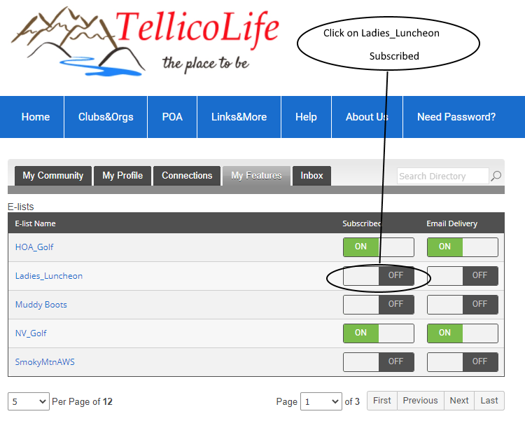

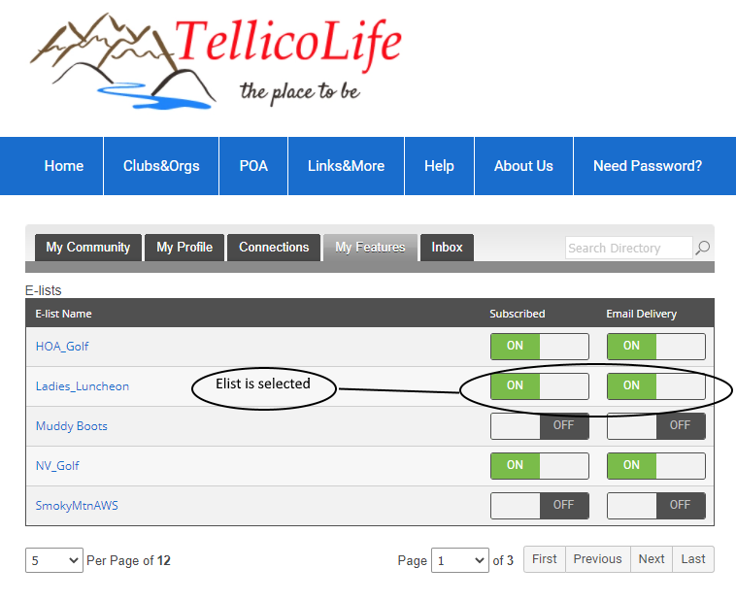
Emails from Ladies_Luncheon@tellicolife.org will land in your email in-basket
You do not need to be logged onto TellicoLife to view or find your emails from Ladies Luncheon. They will be sent directly to your email address.
Replies will go to the sender

